**How to Claim your American Heart Association eCard**

The American Heart Association now offers eCards for certification; digital cards that can be accessed at any time. There is no longer a need to reprint lost or damaged cards, and you will have access to all your training records in one convenient (and shareable) location. Here are the different ways to claim/access your AHA card(s).

**OPTION 1**

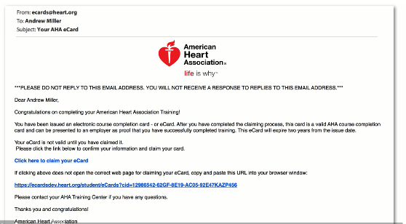After you have been assigned an eCard, you will first receive an email from **ecards@heart.org** (sample below) inviting you to claim your eCard online:

From the email, click on "Click here to claim your eCard". The Student Profile webpage will display:

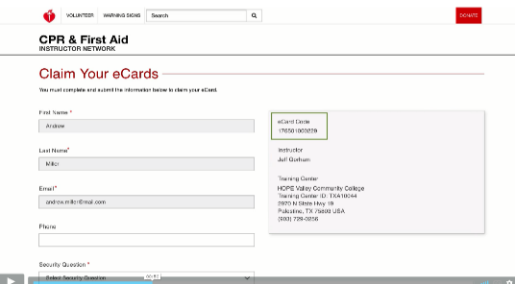

Click on the answer of choice for each section. *You can skip the questions if desired.*

Your eCard will then be displayed on the webpage (sample shown below):

From here you may print/email a **Full-Size Card** or **Wallet-Size Card** (Staff Development needs Full-Size Card)

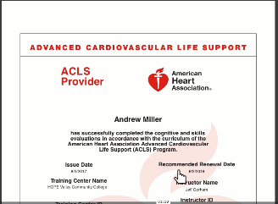

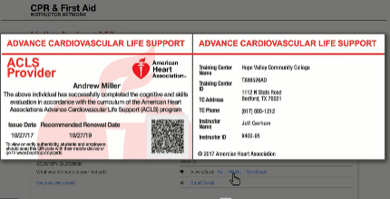

**OPTION 2**

Go to the following website to directly claim your ecard:

**https://ecards.heart.org/student/myecards**

To log into the eCard Profile, simply enter your First Name, Last Name and Email Address

(***must be the email address that you gave in class when signing the roster***).

If you have not already claimed your card, you will have to follow the steps to set up your profile. Once you have set up your profile, you will have unlimited access to all of your AHA Certifications.

**OPTION 3**

You can also access the AHA website via the Northern Regional Hospital Employee Login homepage. Once you have logged on, there is an icon on the employee login dashboard just for American Heart Association. Click the link, then follow the steps in OPTION 2 to claim/view.

If you have any difficulties claiming your eCard, please contact Amanda Allen, Department Coordinator Staff Development, [aallen@wearenorthern.org](mailto:aallen@wearenorthern.org) or 336-783-8354

**Sending in American Heart Association eCard to Staff Development**

Once you have claimed your card, you must complete the final step in order for you to be considered “up to date” with Staff Development and Human Resources.

Staff Development is required by the Joint Commission to maintain current training certifications for all employees within our organization. We work alongside Human Resources to ensure that every employee has up-to-date training and that a copy of their training requirements is kept in their HR file. It is your responsibility as the employee to claim your certification cards and send them in to Staff Development. Once we record our required information, we will pass it along to HR.

Please see the options below for submitting to Staff Development.

**PRINT AND MAIL**

If you choose to print a copy of your FULL-SIZE card, you may “Inter-Dept Mail” it to Amanda Allen in Staff Development

**EMAIL**

If emailing a copy works best for you, please email a FULL-SIZE card to Amanda Allen at aallen@wearenorthern.org

*\* Failure to submit certification cards reflects as expired with Staff Development and Human Resources until a current card has been submitted, regardless of whether Staff Development is aware that you took a class. Being expired in the system can lead to disciplinary action if left unattended for too long.*

Thank you for attending our training session and for taking the time to claim and submit your card. Please let me know if you have any questions.

Thank you!

Amanda Allen, BSN, RN

Dept. Coordinator

Staff Development

336-783-8354 office

336-325-7231 cell

[aallen@wearenorthern.org](mailto:aallen@wearenorthern.org)