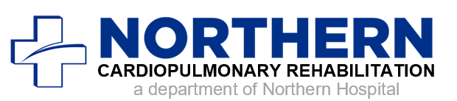

### **3rd Floor**

*Singing is a fun, therapeutic way to exercise your lungs. Benefits include less shortness of breath, increased breathing capacity, better exercise tolerance and overall sense of well-being.*

**Call 336-783-8448 for more information. Please RSVP by phone or email to *aherrington@nhsc.org.***

Northern Hospital

Cardiac & Pulmonary Rehabilitation Unit

830 Rockford Street

3rd Floor

Mount Airy, NC

Phone: 336-783-8448

## Please join us for a fun afternoon of singing with experienced musicians.

## No talent needed, just the desire to have fun!

## Free to the public

A singing support group for people with chronic lung disease.

**Sing at the top of your lungs!**

**August 15, 2019 at 2pm**

## NORTHERN HOSPITAL